Successful connection from Novofarma to OCD:
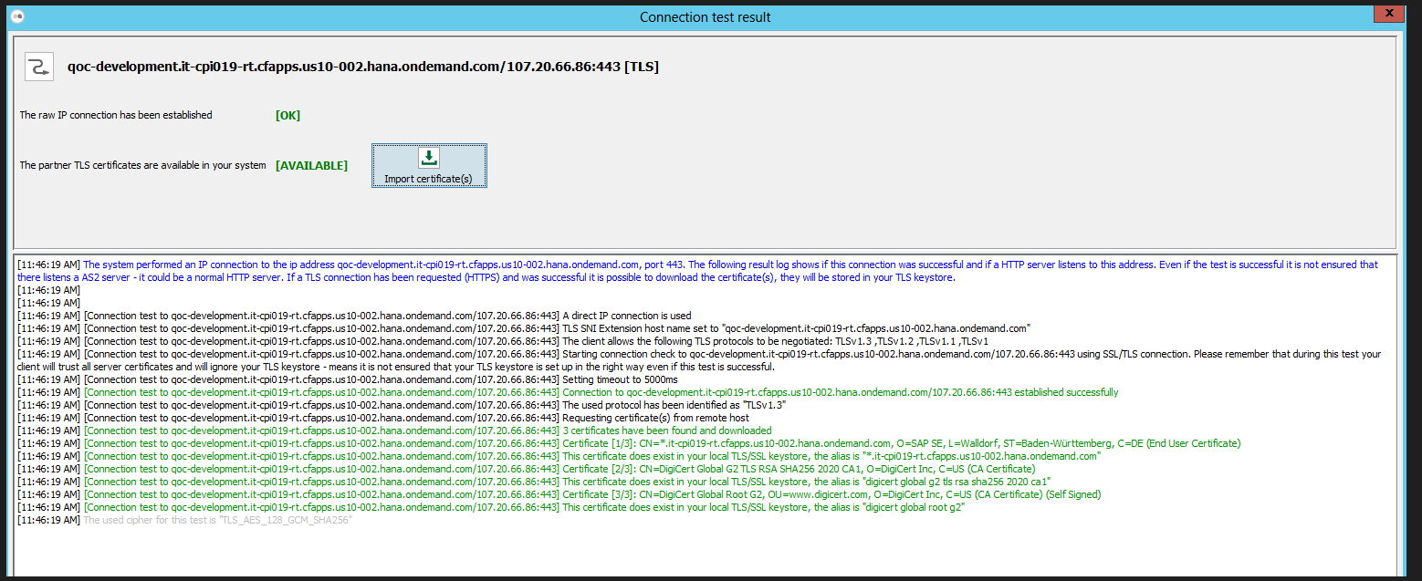
Error while posting data from Novofarma to OCD:
[Aug 20, 2024, 11:55:38 AM] [mendelson_opensource_AS2-COMMUN-1724169331992-12@NOVOFARMA_QO_AS2_DEV_QOBTPDEV] MessageHTTPUploader.performUpload: [SocketException]: Socket is closed
[Aug 20, 2024, 11:55:38 AM] [mendelson_opensource_AS2-COMMUN-1724169331992-12@NOVOFARMA_QO_AS2_DEV_QOBTPDEV] Will retry to send transmission after 30s, retry 1/10.
